**FATIMA JINNAH WOMEN UNIVERSITY, RAWALPINDI**



**SUBMITTED BY: AREEBA ABID (2017-BSE-039)**

**MOMINA SHABIB (2017-BSE-054)**

**SUBMITTED TO: MAM MEHREEN SIRSHAR**

**SUBJECT: DIGITAL IMAGE PROCESSING**

**DOMAIN OF PROJECT: REMOTE SENSING**

**TOPIC: ROAD EXTRACTION FROM SATELLITE IMAGES**



**Table of Contents**

**NEED FOR ROAD EXTRACTION:** 3

**INTRODUCTION:** 3

**OBJECTIVE:** 3

**PROPOSED ALGORITHM:** 4

**EXTRACTION ALGORITHM:** 4

**OTSU’S METHOD:** 7

**MEDIAN FILTERING:** 7

**GUI OF ROAD EXTRACTION FROM SATELLITE IMAGES:** 12

**CONCLUSION:** 16

**ROAD EXTRACTION FROM SATELLITE IMAGES**

**NEED FOR ROAD EXTRACTION:**

In today’s world of growing population, the need for urban planning is very high. In this project, a robust and efficient method for the extraction of roads from a given set of satellite images is explained. Roads play a vital and important role in urban planning and thus, its extraction can be of great help. The other applications of road extraction are: identification of isolated buildings that need to be detected and updating of GIS database according to the requirements of the human expertise. In this method, roads are extracted solely based on their colour. The steps in the algorithm are easy to follow and implement. It is also less time consuming and an automatic method.

# **INTRODUCTION:**

Roads are one of the important man-made objects which have greater significance in transportation. The road network database must be up to date with the current situation and is important to update the database for road maps. The conventional methods for road extraction are very expensive and time consuming. Remote sensing technology is highly effective in providing accurate information for the extraction and updating of roads. High resolution images are obtained from remote sensing methods and the methods of processing are also important to produce accurate results. Remote sensing technologies mainly uses the method of segmentation for extraction of different objects such as roads, buildings etc. from the high resolution satellite images. The high resolution satellite images are processed by multi-resolution segmentation, which deals with high resolution imagery.

In our project we are extracting the roads solely based on their colour. The Multispectral satellite images that we are using in our project is of more than 0.5m resolution. Multispectral Images are those images that consists of three or more spectral bands.

# **OBJECTIVE:**

The objective of our project is to extract roads from high resolution satellite images, as roads plays vital role in urban planning. The roads that are extracted solely based on their colour. We are implementing our project on MATLAB 2015. We are implementing Otsu’s method which automatically sets the threshold value to convert the grayscale image into binary image. Then we applied median filtering to remove the salt pepper noise. After median filtering we apply morphological tools and at last using sobel filtering for edge detection and show the roads on the original image.

# **PROPOSED ALGORITHM:**

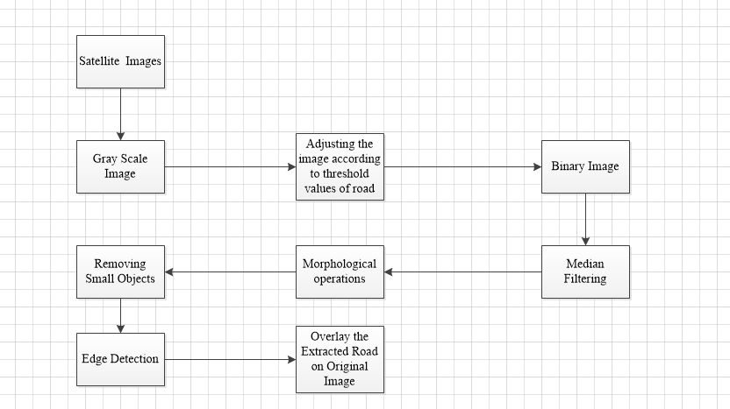

The basic of the algorithm is that the satellite image which is in coloured is converted into the grayscale image and then gray scale image is adjusted according to the threshold values of the road. The obtained image is then converted into binary image using Otsu’s method. Then the image is filtered by using median filtered to remove salt pepper noise from the image. If there are some unwanted objects I the image then it is removed using morphological operations, then the edges of road are extracted using sobel method and finally the road are extracted from the original image and overlay it on the original image.

# **EXTRACTION ALGORITHM:**

At first the coloured image is converted into gray scale image and it is adjusted according to threshold range 0.5 to 0.9 to remove unwanted objects.

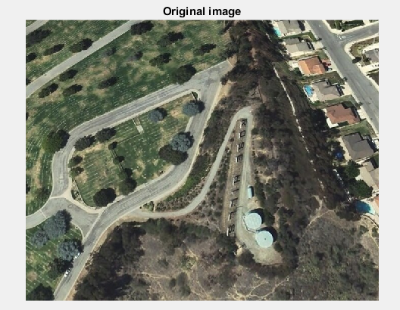

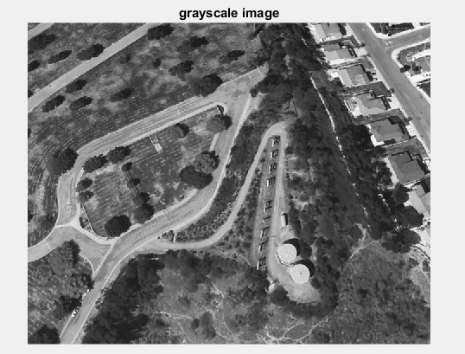

**J=rgb2gray(I);**

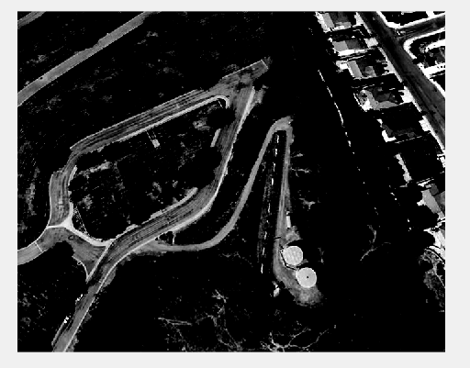

**K=imadjust(J,[0.5 0.9],[]);**

Then the image is converted to a binary image using ‘graythresh()’ i.e., Otsu’s method which automatically sets the threshold value for the conversion. The figure below shows the image obtained after converting to binary.

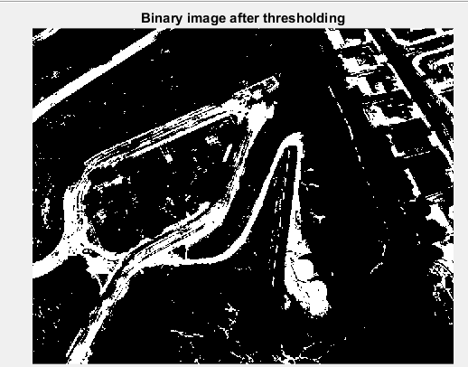

**level = graythresh(K);**

**B_W=im2bw(K,level);**

# **OTSU’S METHOD:**

Otsu’s thresholding method corresponds to the linear discriminant criteria that assumes that the image consists of only object (foreground) and background, and the heterogeneity and diversity of the background is ignored. Otsu set the threshold so as to try to minimize the overlapping of the class distributions.

In Otsu’s method, we exhaustively search for the threshold that minimizes the intra-class variance (the variance within the class), defined as a weighted sum of variances of the two classes:

https://projectsflix.com/wp-content/uploads/2018/09/pro-001-300x45.jpg

Where W0 and W1 are the probabilities of the two classes separated by a threshold t, and sigma not and sigma one are the standard deviations of these two classes.

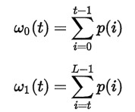

Otsu shows that minimizing the intra-class variance is the same as maximizing inter-class variance.

https://projectsflix.com/wp-content/uploads/2018/09/pro-003-300x46.jpg

The class probabilities and class means can be computed iteratively. This idea yields an effective algorithm.

# **MEDIAN FILTERING:**

After converting the image into binary using OTSU’S Method, the median filter is applied on the image to reduce the noise from satellite images. The median filter is used because it is best method of filtering the salt pepper noise from the image.

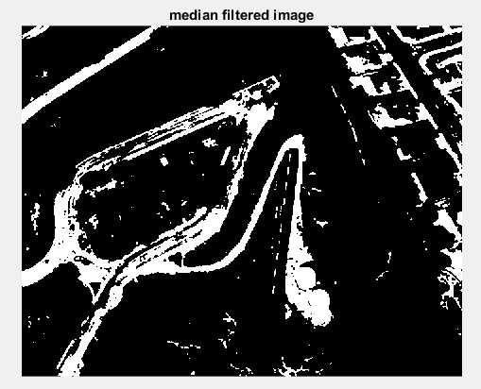

**B = medfilt2(B_W);**

From the median filtered image small objects are removed which are unnecessary and whose pixels are less than 60 using ‘bwareaopen’. This helps in removing buildings and small parking slots. The image after removing small pixels is given below.

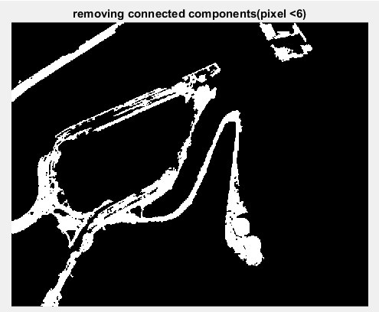

**im = bwareaopen(B,1200);**

There are still some unwanted objects in the image so to remove it we are using morphological operations. Morphological operations are those operations used to remove undesired pixels based on the foreground and the background of an image. The morphological operations are used on the binary image.

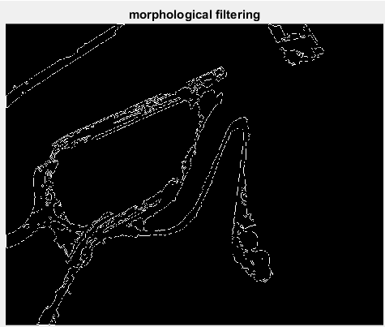

**BW = bwmorph(im,'remove');**

After applying the morphological operations we get the clean roads but it is very important to obtain the edges of these roads for clear identification of the roads. Gradient filter is used for the edge detection and the type of operator used for the detection is ‘sobel’. Sobel operator is used because the edges are extracted with greater accuracy.

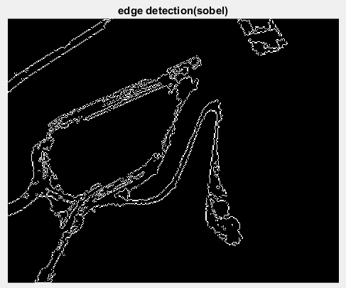

**BW1 = edge(BW,'sobel');**

The final step is to overlay the extracted road onto the scalar image of the original image.

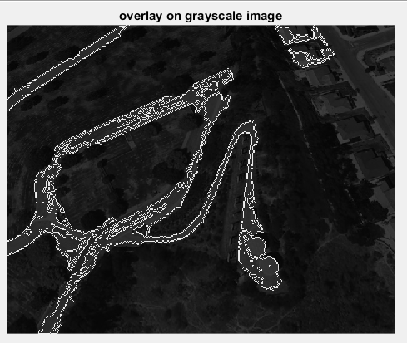

**H = vision.AlphaBlender;**

**J = im2single(J);**

**BW1 = im2single(BW1);**

**Y = step(H,J,BW1);**

# **GUI OF ROAD EXTRACTION FROM SATELLITE IMAGES:**

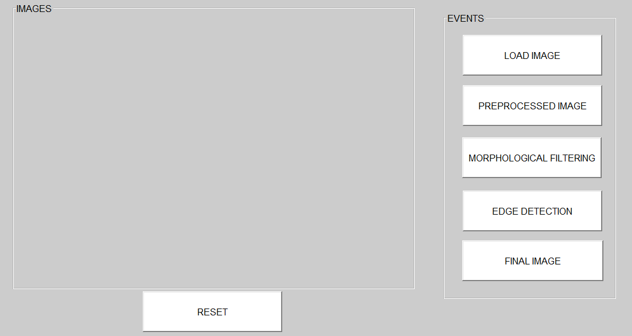

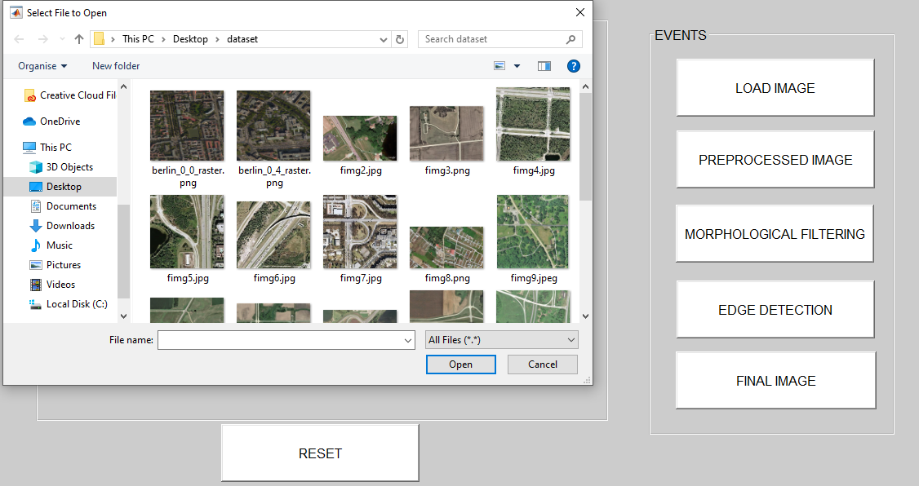

**LOAD IMAGE:**

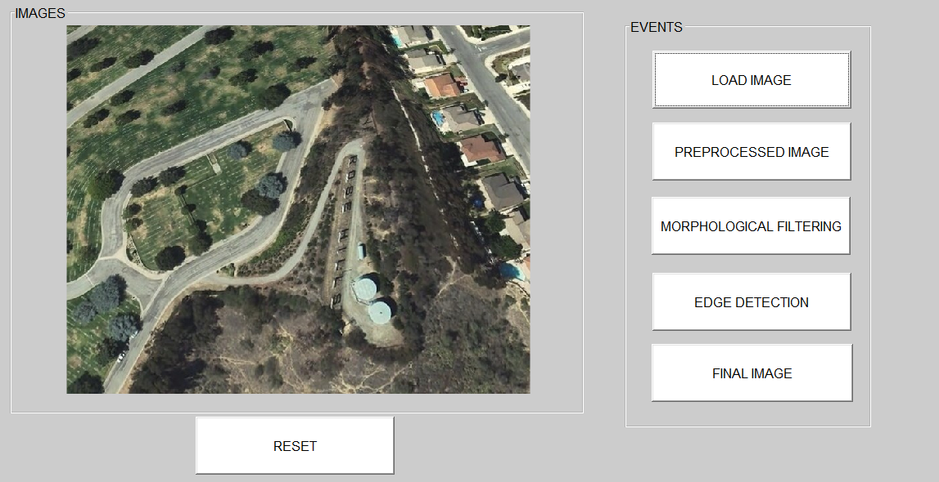

**PREPROCESSED IMAGE:**

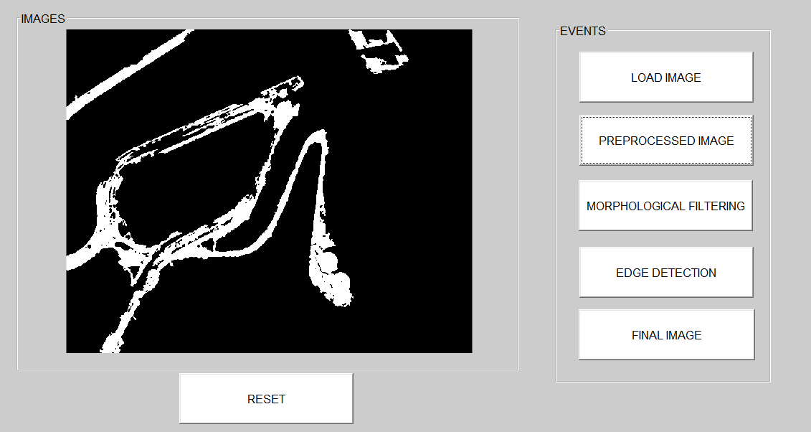

**MORPHOLOGICAL OPERATIONS:**

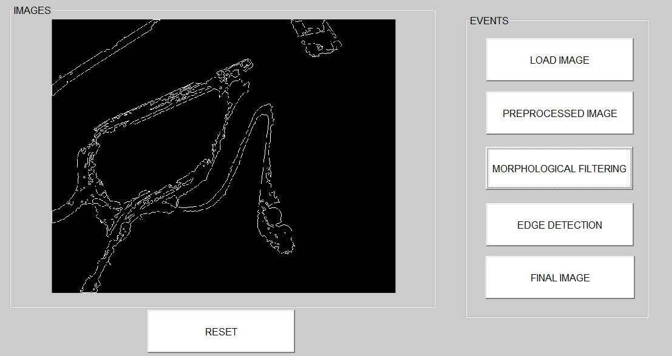

**EDGE DETECTION (SOBEL)**

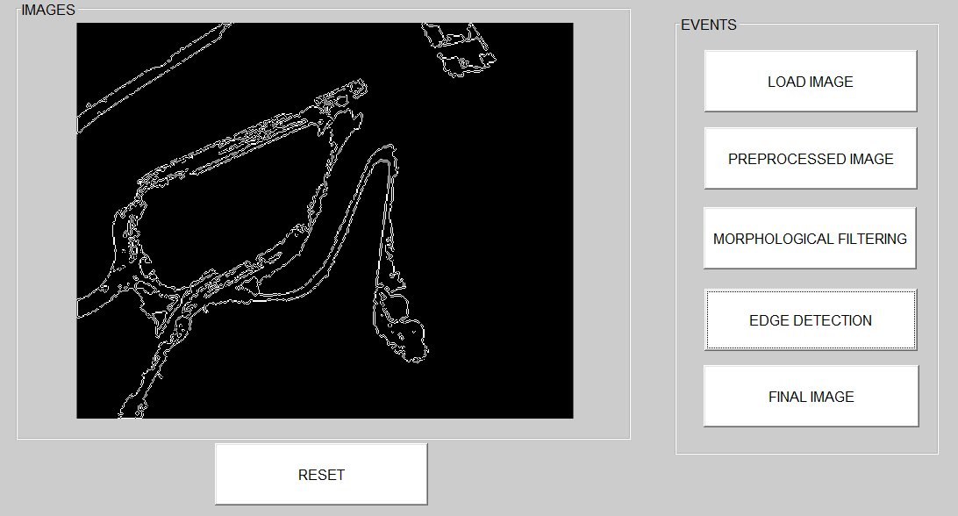

**FINAL IMAGE:**

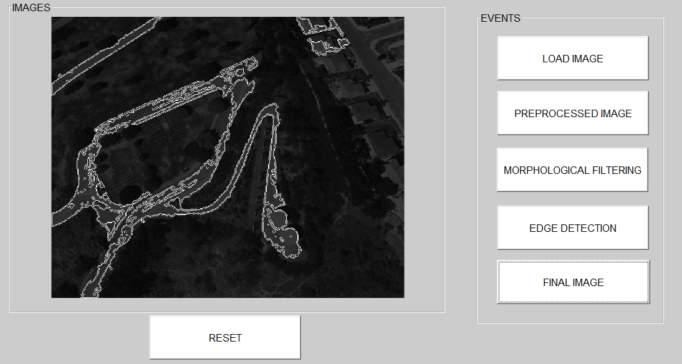

**RESET BUTTON:**

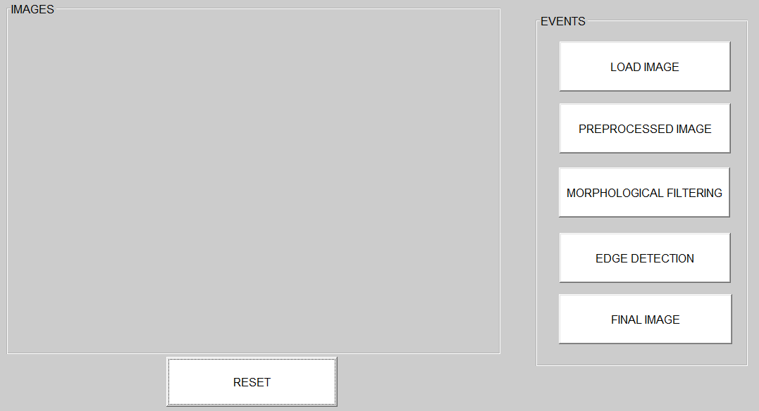

**IF IMAGE IS NOT LOADED:**

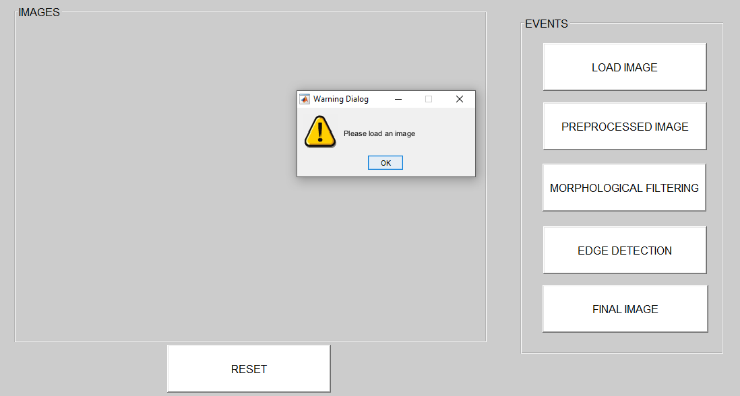

# **CONCLUSION:**

The algorithm that we have introduced is automatic one. Through this algorithm different types of roads is extracted from satellite images with resolution 5m. Extraction is solely based on colour, therefore different barren lands and small area of parking lots will also being extracted. Hence we deduce the algorithm that is automatic, robust, fast and easy to understand as well as to implement it